Data dog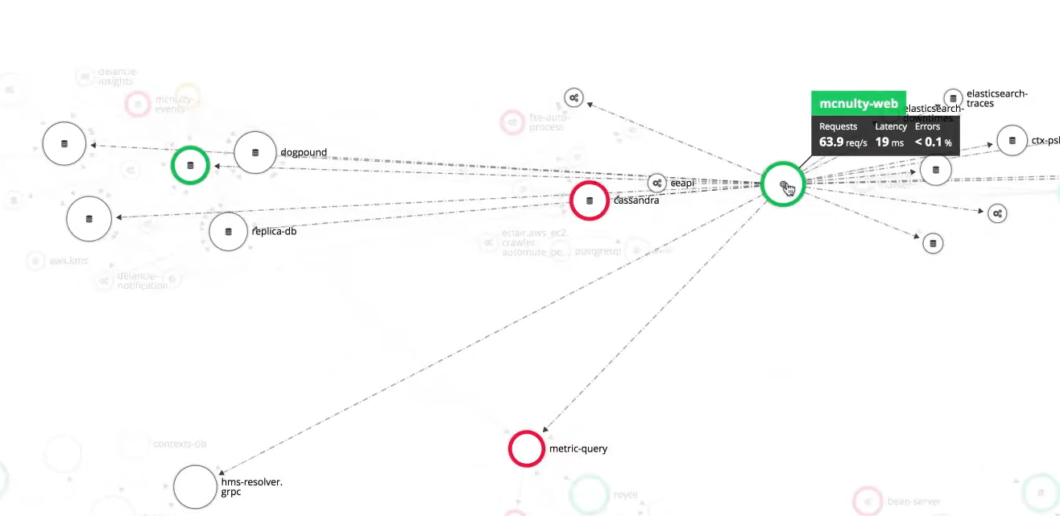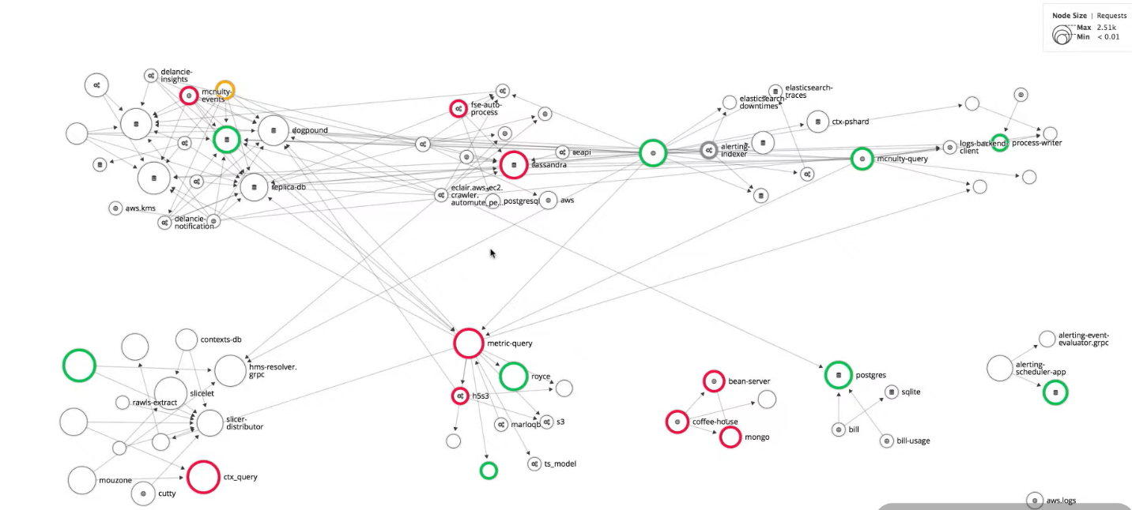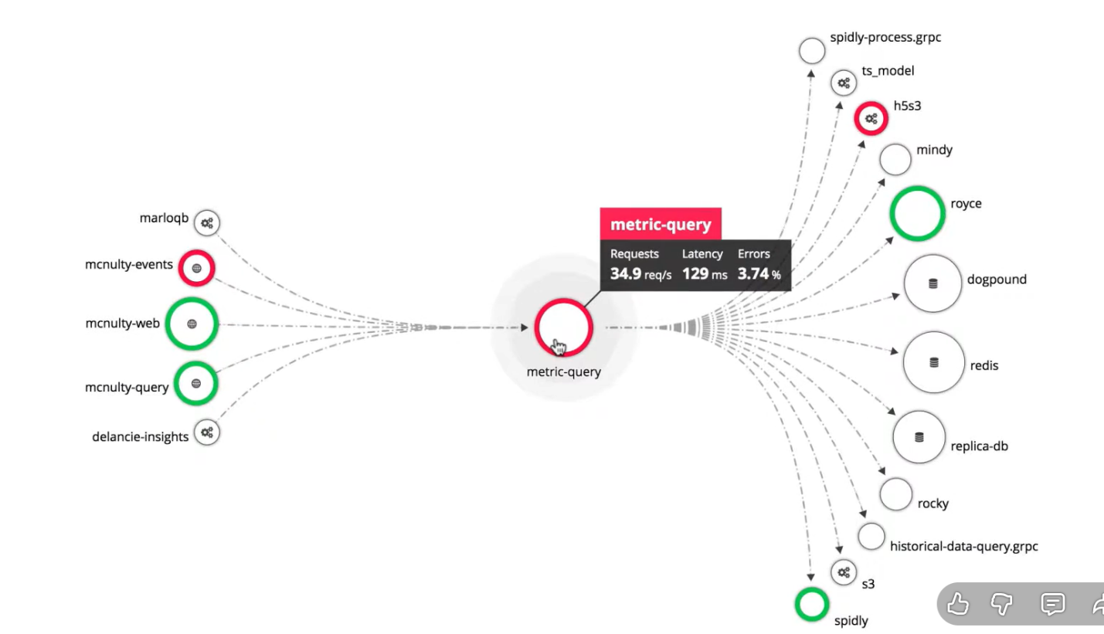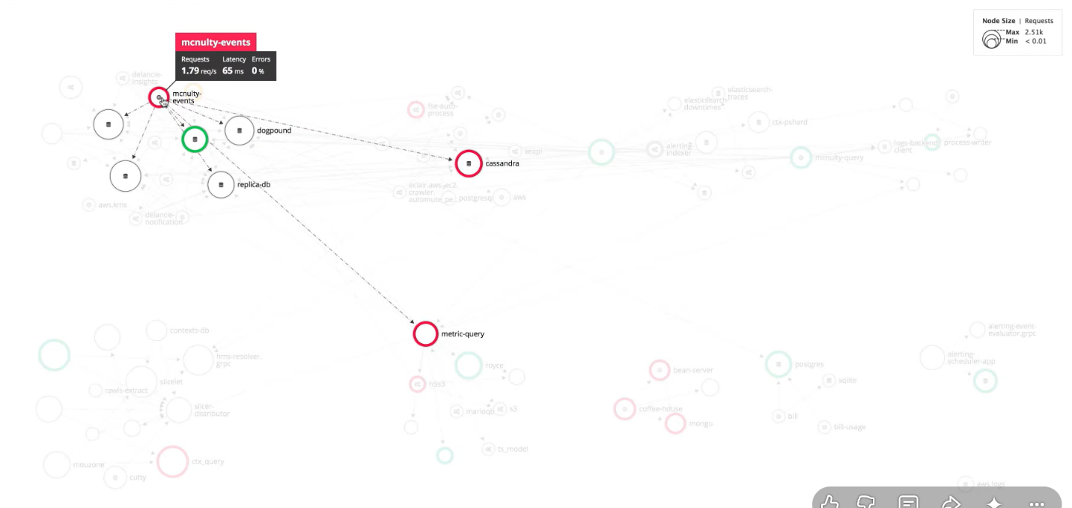

Dyna trace smart scape

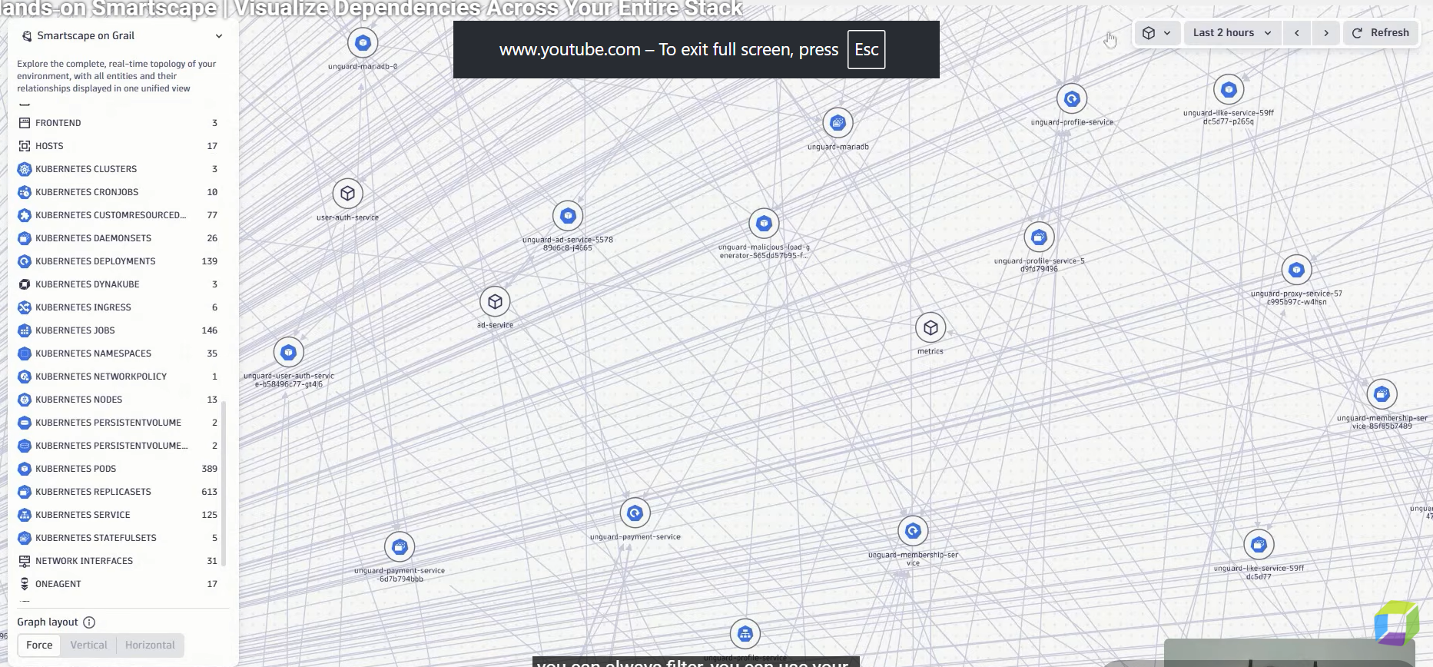

Cloud zero
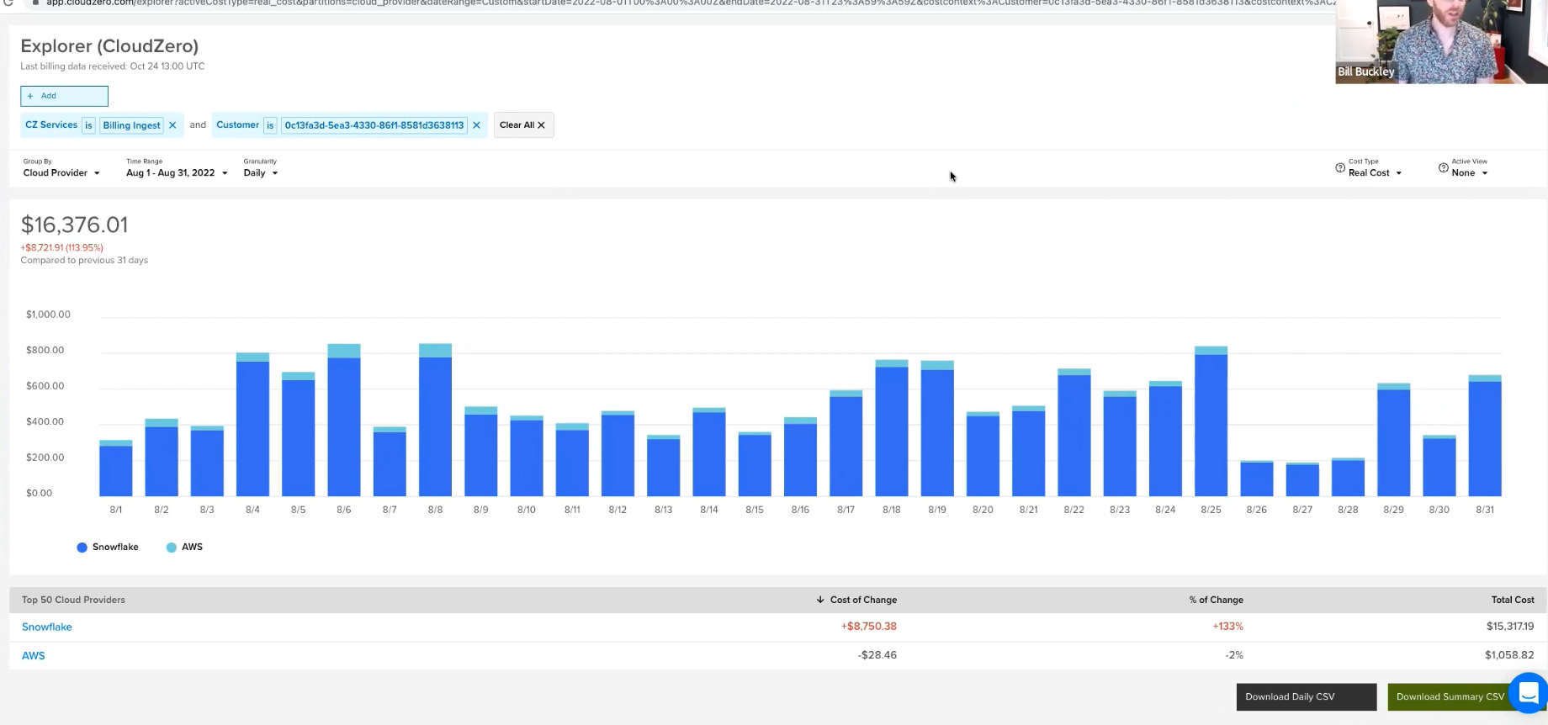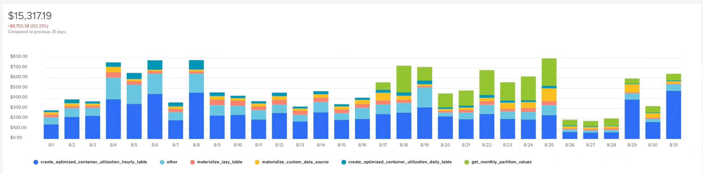
Net Data

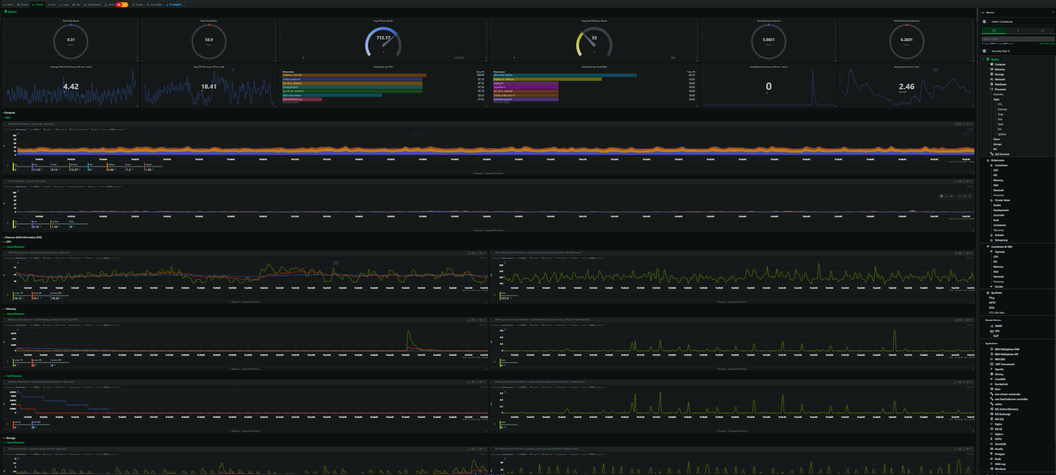
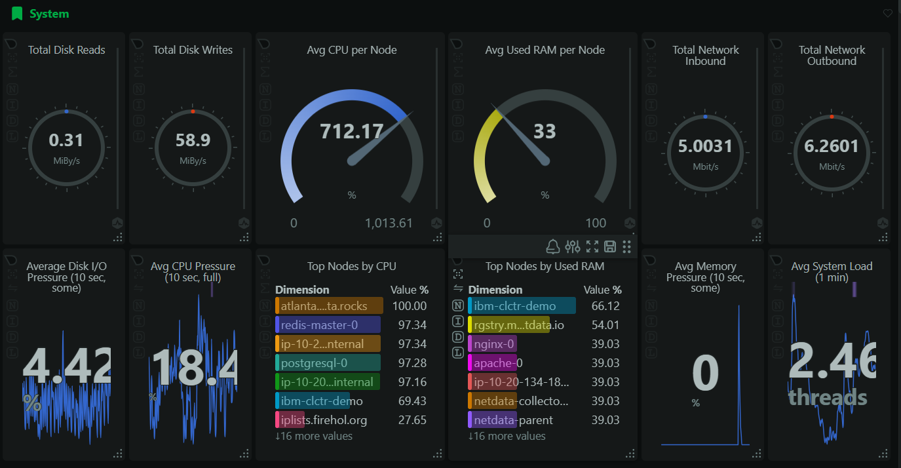
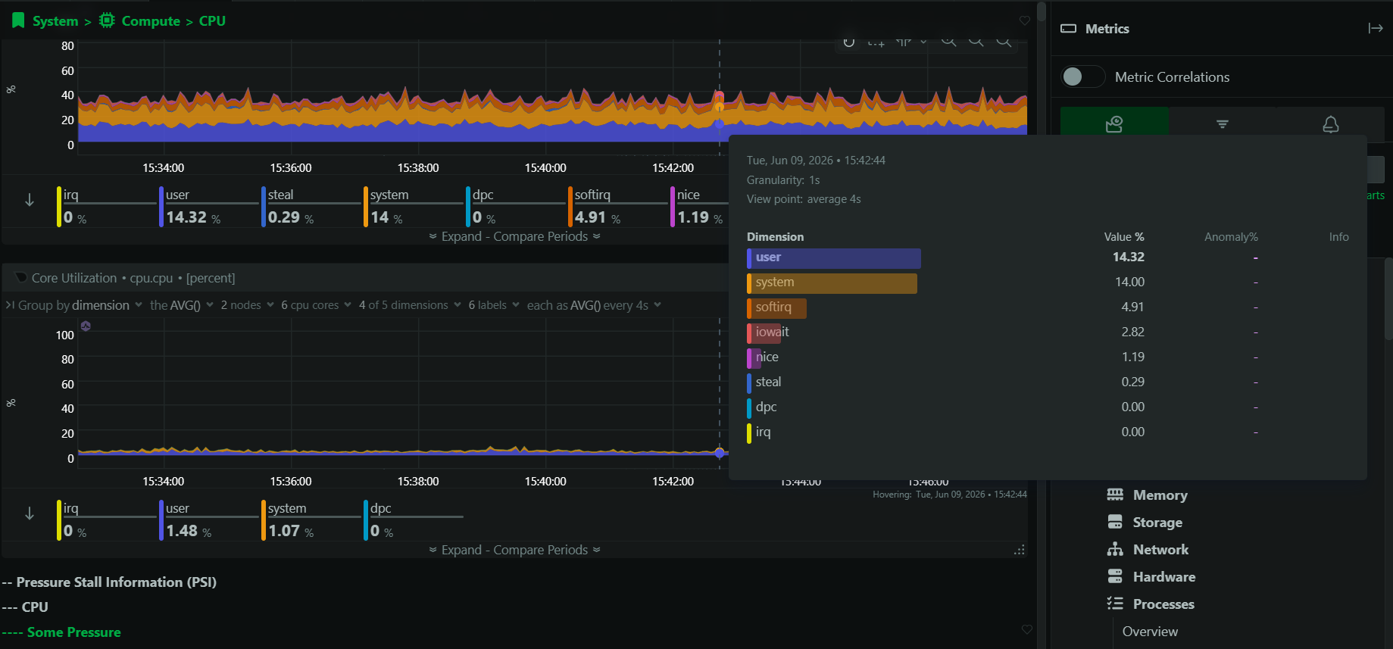
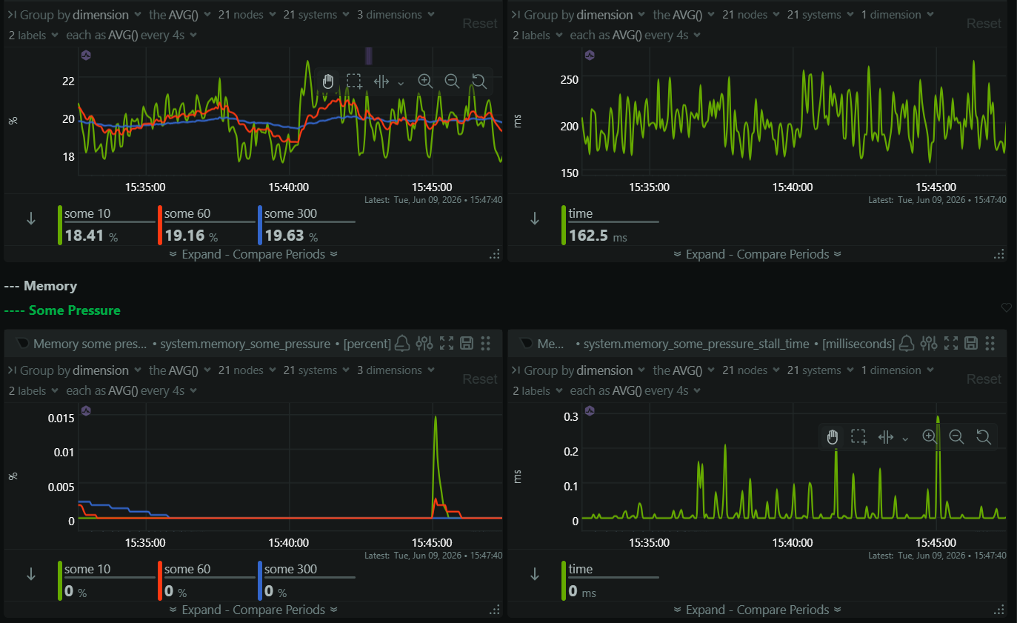

Compute Layer
Network Layer
Security Layer
Storage Layer
Cost Layer
Monitoring Layer
Ownership Layer

Example 1: Explicit Relationship (100%)
Lambda triggered by SQS:
{
"source": "SQS",
"target": "Lambda",
"type": "event_trigger",
"confidence": 100
}
AWS directly exposes:
lambda:list-event-source-mappings
which contains:
{
"EventSourceArn": "arn:aws:sqs:..."
}
There is no guessing involved.

Example 2: Strong Evidence (90%)
EC2 → RDS
Suppose:
- EC2 security group allows outbound to port 5432
- RDS security group allows inbound from EC2 SG
- Same VPC
- Same subnet group
You can infer:
{
"source": "EC2",
"target": "RDS",
"confidence": 90
}
But AWS never says:
"This EC2 instance is connected to this RDS."
Maybe the application never uses the database.

Example 3: Probable (70%)
Lambda → DynamoDB
You inspect IAM policy:
{
"Action": [
"dynamodb:GetItem",
"dynamodb:PutItem"
],
"Resource": "*"
}
You know Lambda can access DynamoDB.
But:
- Which table?
- Is it actually used?
Not certain.
{
"source": "Lambda",
"target": "DynamoDB",
"confidence": 70
}

Example 4: Weak Inference (50%)
Suppose:
- Lambda
- S3 bucket
- Same project tags
- Same naming convention
image-processor-lambda
image-uploads-bucket
No trigger.
No policy.
No event notification.
You suspect a relationship but can't prove it.
{
"confidence": 50
}

Why this matters for Gravity Lens
Imagine a customer with:
- 2,000 resources
- 8 AWS accounts
- 300 Lambdas
If Gravity Lens draws:
Lambda A ── DynamoDB
Lambda A ── S3
Lambda A ── SNS
Lambda A ── SQS
Lambda A ── EventBridge
without confidence levels, the customer will ask:
"How do you know Lambda A uses this DynamoDB table?"
You need an answer.
With confidence scoring:
🟢 100% Verified
🟡 80% Likely
🟠 60% Inferred
the user immediately understands:
- Green = AWS explicitly told us
- Yellow = strong evidence
- Orange = educated guess

An even better model
Instead of only a number, store the evidence.
{
"source": "lambda-1",
"target": "table-1",
"confidence": 75,
"evidence": [
"IAM policy allows DynamoDB access",
"Environment variable TABLE_NAME=users",
"Same CloudFormation stack"
]
}
Then when the user clicks the edge:
Lambda → DynamoDB
Confidence: 75%
Evidence:
✓ IAM policy permits access
✓ TABLE_NAME environment variable references table
✓ Created in same stack
✗ No CloudWatch logs confirming usage
This becomes a major differentiator from AWS diagrams because you're not just showing lines—you can explain why the line exists.
For Gravity Lens, I'd actually store:
interface Relationship {
source: string;
target: string;
type: RelationshipType;
confidence: number;
evidence: Evidence[];
discoveryMethod:
| "explicit"
| "configuration"
| "iam"
| "network"
| "logs"
| "inference";
}
The evidence is often more valuable than the confidence score itself, because it lets users verify and trust the relationship.

Relationship engine Pipeline

Network topology confidence
Evidence | Score
Same VPC | +10
SG reference | +40
Matching port | +20
Same subnet | +5
Target Group | +40
VPC endpoint | +30

